**SMART WATER FOUNTAINS**

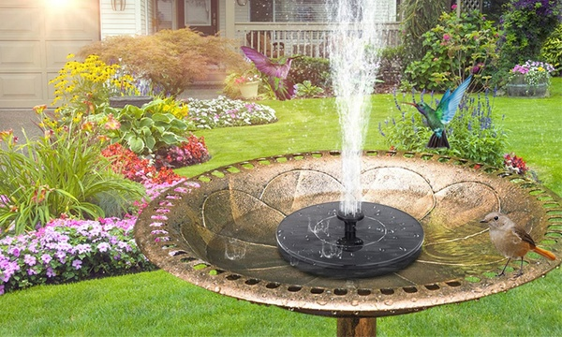

**1.Aesthetic Design:**

* Determine the overall style and theme of the fountains, which can range from traditional to modern, minimalist ornate.
* Select materials the complement the surrounding environment, such as stone, glass, metal, or acrylic.
* Incorporate decorative elements like sculptures, figurines, or unique basin design to enhance the visual appeal.

**2.Size and Location:**

* Decide on the size and scale of the fountain based on the available space and the desired visual impact.
* Consider the location of the fountains, whether it’s indoors or outdoors, and ensure that it fits seamlessly within the environment.

**3.Water flow and Effects:**

* Determine the type of water flow and effects you want, such as cascading waterfalls, laminar jets, or gentle bubbling.
* Use multiple levels, tiers, or basins to create dynamic water patterns and maximize visual interest.

**4.Lighting Design:**

* Integrate RGB LED lighting to illuminate the water and surrounding areas.
* Plan the lighting effects, including color changes, intensity adjustments, and synchronized pattern to create a captivating visual display.

**5.Smart Technology Integration:**

* Microcontrollers or IoT devices to control the fountain’s functions.
* Smartphone app or touchscreen interface for user control.
* Remote monitoring and control options for maintenance and adjustments.

**Design**

Size and Location

Sound Design

Water Flow and Effects

Safety Measures

Lighting Design

**Smart Water Fountain**

Interactive Features

Power and water supply

Smart Technology Integration

**6.interactive Features:**

* Consider interactive elements to engage users, such as touch-sensitive panels, proximity sensors, or responsive water jets that react to movement.

**7.Sound Design:**

* Plan for audio elements if desired, such as soothing background music, nature sounds, or the calming sound of flowing water.

**8.Safety Measures:**

* Ensure the safety of users by designing the fountain with protective barriers or covers for moving parts.
* Incorporate features that prevent water splashing or overspray.

**9.Maintenance and Accessibility:**

* Design the fountain with easy access to components for maintenance and cleaning.
* Include features like self-cleaning mechanisms or automated water treatment systems to reduce maintenance needs.

**10.Power and Water Supply:**

* Determine the power source for the fountain’s components, which may require electrical outlets or solar panels for sustainability.
* Ensure a reliable water supply and a proper drainage system.

**11.weather Resistance (for outdoor fountains):**

* If the fountain is outdoors, select materials that can withstand various weather conditions, including UV rays, rain, and freezing temperatures.